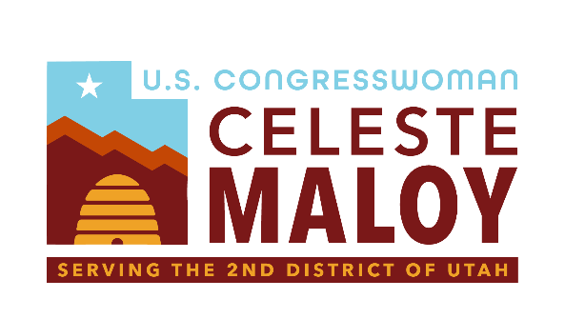

Shivwits Band of Paiutes Jurisdictional Clarity Act

Serving Utah’s Second District

Background
The Shivwits Band of Paiutes (the “Shivwits Band”) seeks jurisdictional clarity for civil causes of action on Shivwits Band Indian lands to ensure that both the Shivwits Band and third parties seeking to engage in business and development on Shivwits Band Indian lands have access to a state or federal court forum to resolve disputes.
Problem
The Shivwits Band is in need of a clear legal framework establishing a path to resolution of civil actions arising on Shivwits Band Indian lands. Without this clear legal framework, the Shivwits Band cannot engage investors in furtherance of its economic development and is unable to put its Indian lands to the highest and best use.
Solution
This legislation affirms Utah State court jurisdiction over civil cases involving the Shivwits Band that occur on its Indian lands. Civil disputes can now definitively be resolved in a Utah State court forum, offering a clearer legal structure to potential investment partners and the Shivwits Band itself. The legislation also ensures that the Shivwits Band’s sovereign immunity remains intact unless explicitly waived by the Band. This safeguards the Shivwits Band’s immunity from unconsented suits while ensuring that the Shivwits Band is able to consent to Utah State court jurisdiction in contracts and agreements to which the Shivwits Band is a party.
In addition to Utah State court jurisdiction, the legislation also ensures that Federal court is available to resolve disputes arising under contracts to which the Shivwits Band is a party. These disputes are treated as civil actions arising under federal law, providing further clarity on accessible forums in which to resolve issues arising on Shivwits Band Indian lands.
Lastly, the legislation expands existing law to provide the Shivwits Band with the same ability already afforded to numerous other tribes, so that the Shivwits Band may agree to leases of its Indian lands for extended terms. This aims to support economic development within the Shivwits Band’s community.

