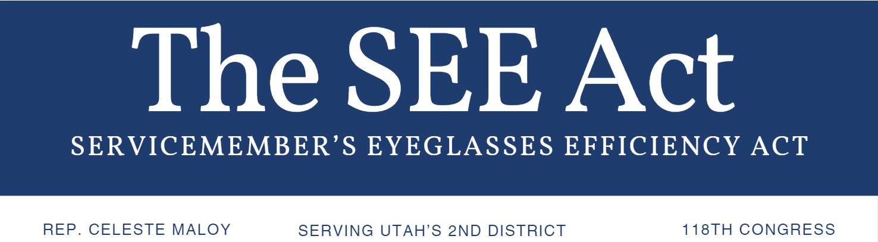
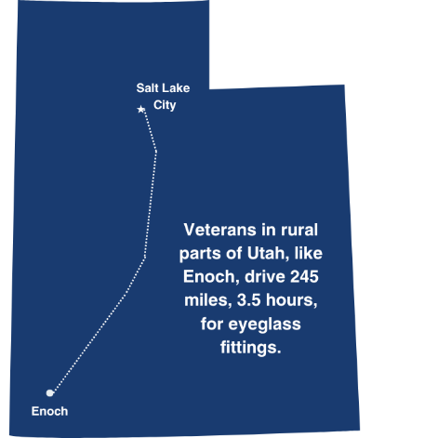
The Problem Facing Rural Veterans
A quarter of U.S. vets (6.4 million) live in rural parts of the country and one third wear glasses. VA Community Care Networks, created by the Mission Act in 2018, allow some veterans to access basic care in their communities without traveling to VA facilities.
The Mission Act lists “optometric services” and “vision testing” as covered by CCNs, but the VA does not consider eyeglass fittings to be covered.

The SEE Act Would
- Add eyeglass fittings to the list of Community Care Network treatments, benefitting millions of U.S. vets.
- Save the VA money in travel and lodging reimbursement costs.
- Address the concerns of the most remote American veterans who face the longest distances for care.
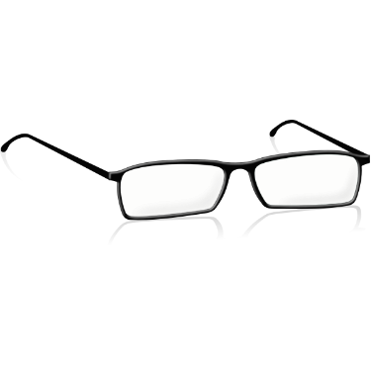
To cosponsor the SEE Act contact
Nathan Tenney | Legislative Aide
nathan.tenney@mail.house.gov or (771) 233-1019

