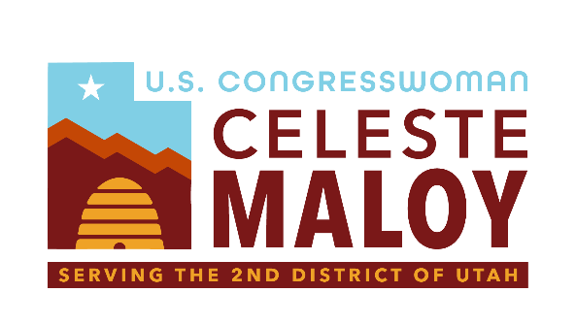

Pharmacist Audit and Compensation Transparency (PhACT) Act
Serving Utah’s Second District

The Role of PBMs in U.S. Healthcare
Pharmacy Benefit Managers (PBMs) – the middlemen of drug pricing – have been reimbursing independent and other retail community pharmacists at lower rates each year for nearly a decade. When pharmacists sell medicines to insured customers the insurance companies reimburse PBM companies who in turn reimburse pharmacists. In some cases, these reimbursements have fallen to lower than the cost of the medicines.
So far in 2024, pharmacists report thousands of store closures and in a survey conducted by the National Community Pharmacists Association, one in three independent pharmacists said they were considering closing their doors for good. Many pharmacists report failing PBM audits as the primary reason they cannot stay in business.
The Problem with PBM Audits
Pharmacists in Utah first brought PBM audits to our attention. PBMs often audit pharmacists when issuing reimbursements and pharmacists widely report these audits are a pretense for withholding additional reimbursement funds. These audits lack clear metrics for pass or failure and often include requirements without clear medical rationale.
One example offered by a Utah pharmacist was the requirement to prove medicines were purchased within 14 months despite approved FDA expiration dates that far exceed that amount of time. Though PBM companies contest these claims, these audits lack transparency and aren’t well understood by government regulators.
The Solution: Pharmacist Audit and Compensation Transparency (PhACT) Act
Congresswoman Maloy is leading a bill to investigate these audits and find solutions that will bring transparency, fairness, and ease the burden on pharmacists. While PBM practices have come under increased scrutiny more research into PBM audits is needed to craft the best reforms. The Pharmacy Benefit Manager Accountability Act directs the Secretary of Health and Human Services to conduct a thorough investigation of PBM audits and make recommendations for fairness and transparency.

