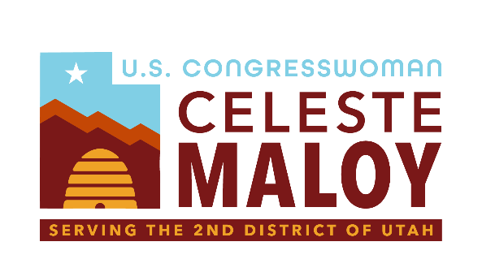

The Ending Presidential Overreach on Public Lands Act

Serving Utah’s Second District
Background
The Antiquities Act (signed into law in 1906 by President Theodore Roosevelt) gave the President of the United States the authority to designate national monuments from federal lands to protect significant natural and historic features throughout the United States. Since its enactment, it has been used over a hundred times to create national monuments.
Problem
President Biden has actively sought to lock up millions of acres of land through his so-called “America the Beautiful Initiative”, oftentimes resulting in entire communities being prevented from using the resources in their own backyards for recreational or economic use.
Solution
The "Ending Presidential Overreach on Public Lands Act" gives Congress authority over national monument designations by striking Section 2 from the Antiquities Act. This bill emphasizes the importance of Congressional oversight in the designation and modification of national monuments. This legislation:
- Restores Congressional Authority: The bill gives Congress the sole power to modify or revoke national monument designations.

- Limits Presidential Power: The bill prevents the President from making unilateral decisions regarding national monuments, thereby promoting a more balanced approach to land management.
The "Ending Presidential Overreach on Public Lands Act" promotes responsible land management and ensures that decisions regarding national monuments are made with appropriate checks and balances.

